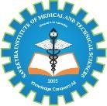

SIMATS ENGINEERING

Saveetha Institute of Medical and Technical Sciences
Chennai- 602105

Student Name: A.THARUN,A.MEGHANADH
Reg. No.: 192572068,192572132
Course Code: CSA1711
Slot:C
Course Name: ARITIFICAL INTELLIGENCE
Course Faculty: Dr. K.KRISHNAKUMAR

Project Title: FAKE NEWS DELECTION SYSTEM
Module Photographs: (3 photographs –Module Photo, Individual student contribution module work in the project and presentation image)
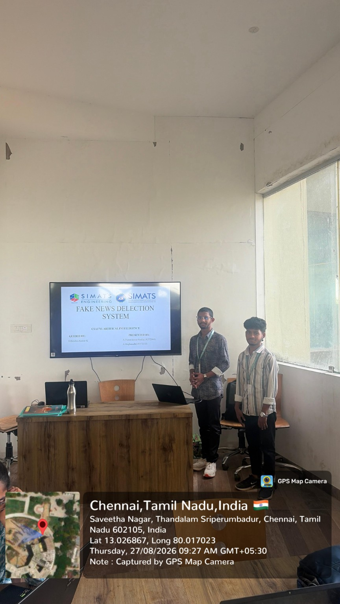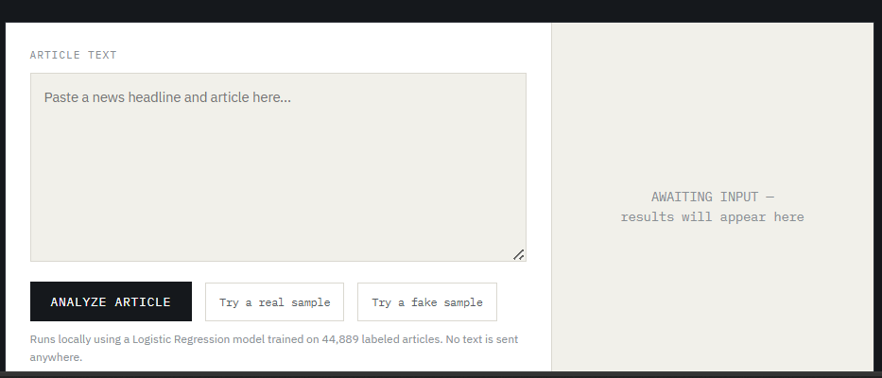

Project Description:
The Fake News Detection System is a machine learning-based application developed to identify whether a news article or textual information is likely to be Fake or Real. The rapid growth of social media, online news platforms, blogs, and digital communication has made information easily accessible. However, it has also increased the spread of misleading, manipulated, and fabricated information. Fake news can influence public opinion, create confusion, damage reputations, and affect important decisions. Therefore, an automated system for analysing and classifying news content can be useful for the initial identification of potentially misleading information.The proposed system uses Natural Language Processing (NLP) and Machine Learning techniques to analyse textual news content. A labelled dataset containing news articles and their corresponding categories is used as the input for the system. The dataset is first processed to handle missing values and prepare the textual information for analysis.

Student Signature Guide Signature

